Chapter 12, Solution 85.

Let 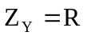

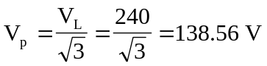

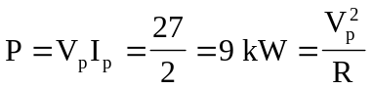

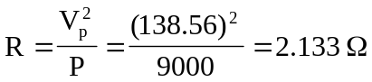

Thus, 